**Visibility Conditions- Within same UI If any conditions are applied those are Visibility Condition.**

**Visibility conditions we can apply in 2 ways. ( Property Level & Layout Level)**

**Visibility conditions we can apply using When Rule/Condition Expression( Single Value) or Condition Expression ( Page Properties)**

**Req:**

**Applying Visibility Conditions at Layout level & Field Level using Condition Expression (if)**

**- Claims details layout should be visible when vehicle has any prior insurance(Prior Insurance is Yes)**

**- Claim Amount & Claim Reason should be visible if vehicle has any Prior claims (Prior Claims is true Check box is Selected)**

**Open Section Rule & Apply Condition Expression:**

**Double Click on Claims Layout settings:**

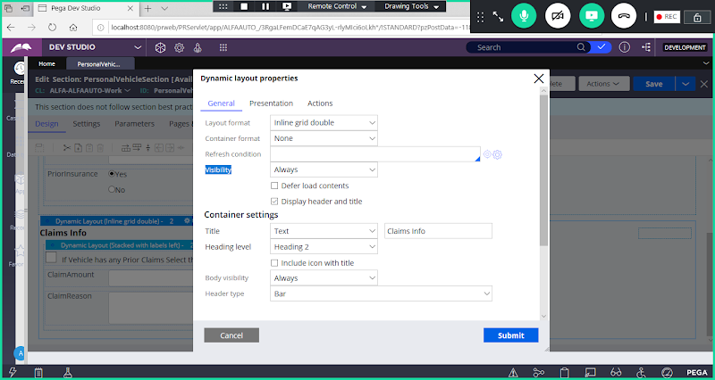

**Visibility : select Condition Expression**

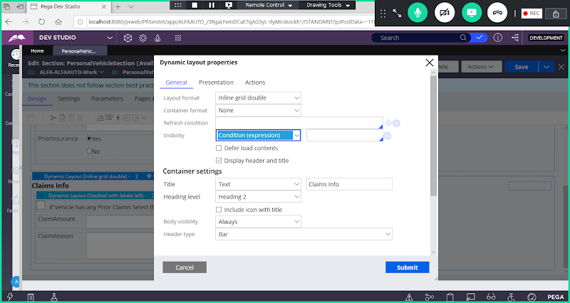

**Now Add Condition**

**.PersonalVehiclePage.PriorInsurance=="Yes"**

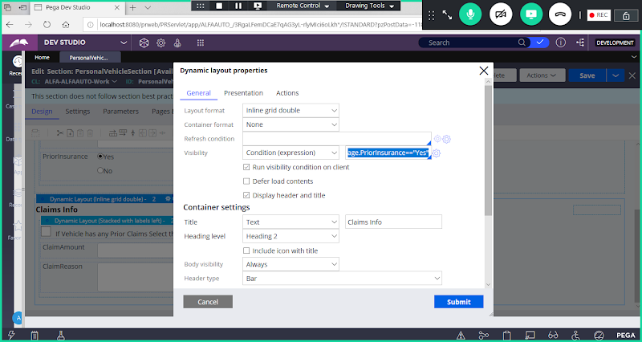

**Submit**

**Now Add Condition for ClaimAmount & Claim Reason**

**Click on Cliam Amount Property:**

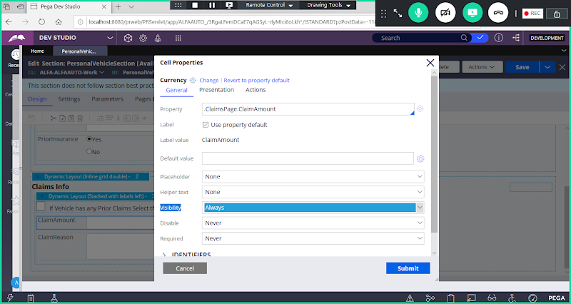

**Select Condition (Expression)**

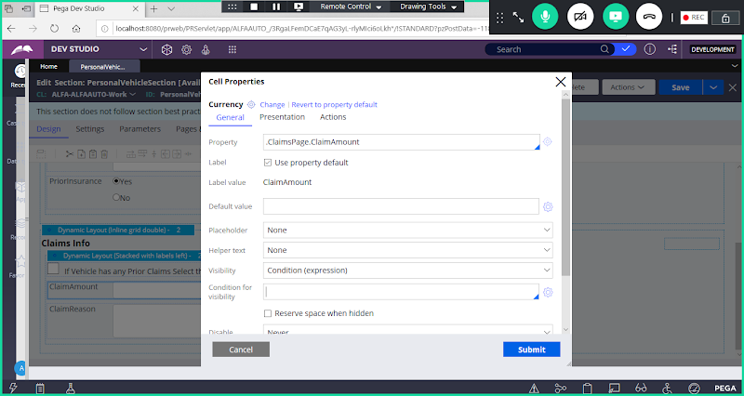

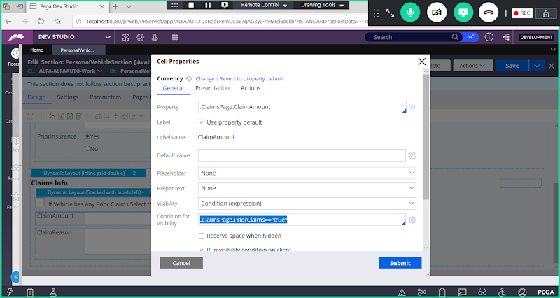

**.ClaimsPage.PriorClaims=="true"**

**Submit**

**Similarly Add  Condition (Expression) for Claim Reason Property:**

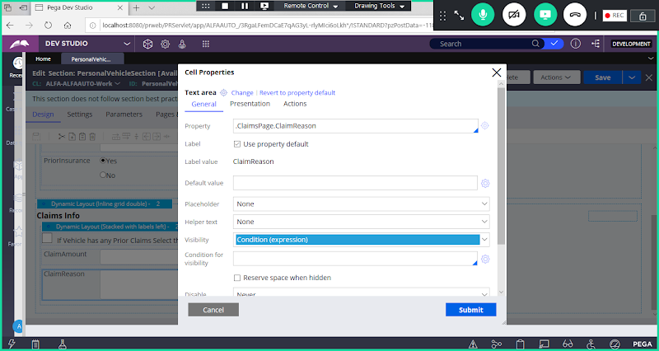

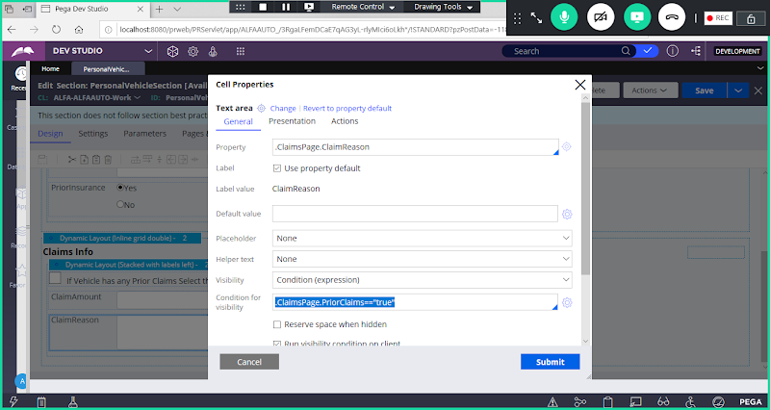

**.ClaimsPage.PriorClaims=="true"**

**Submit & Save section**

**Set Event & Action for Radio button & Check box Property:**

**Set For Radio Button Property:**

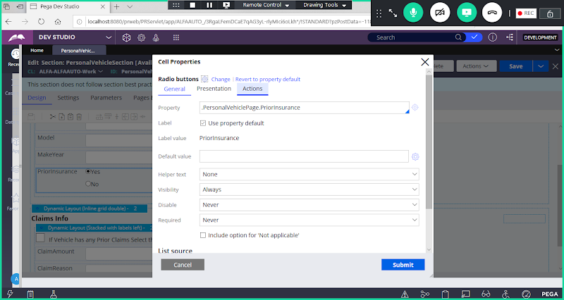

**Click on Actions Tab:**

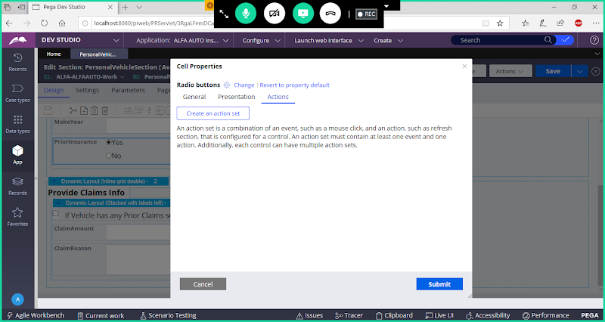

**Click on create an Action Set**

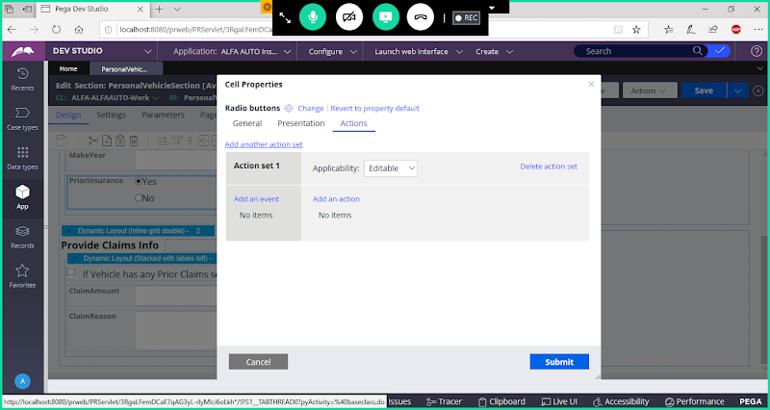

**Event : Click**

**Action Name: Display Refresh**

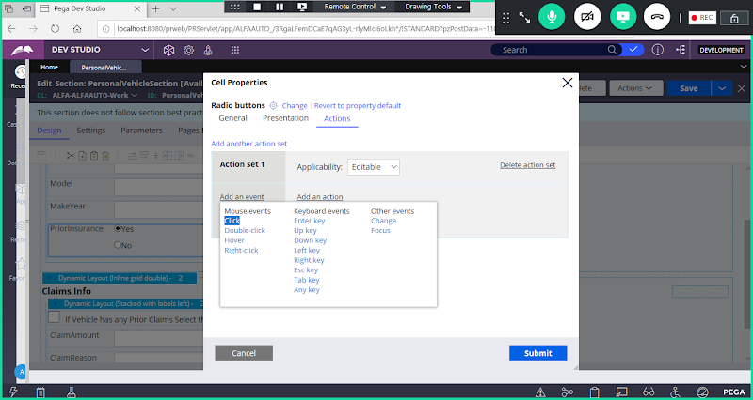

**Select Click**

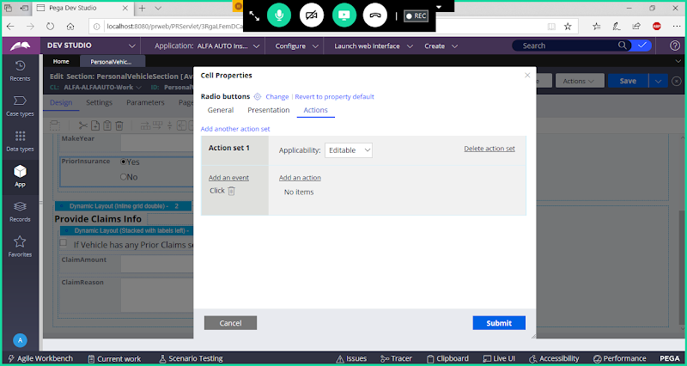

**Now Click on Add an Action:**

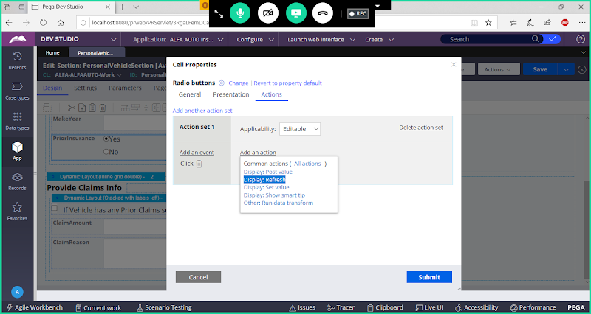

**Select Display Refresh**

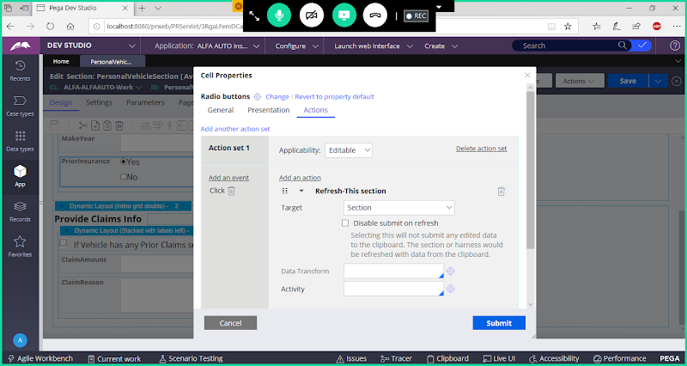

**Submit**

**Similarly for Check box Property:**

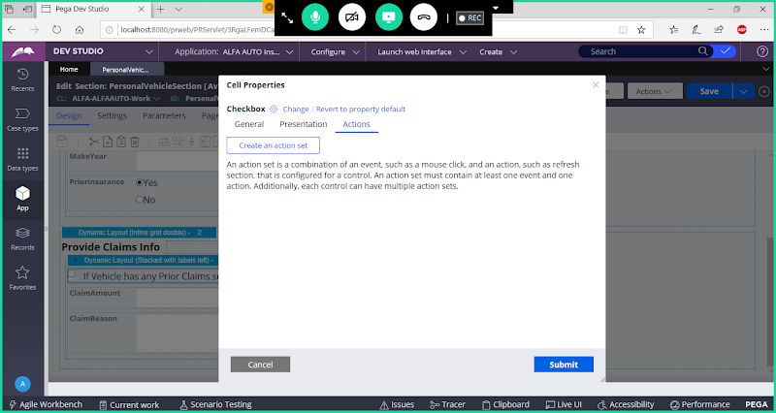

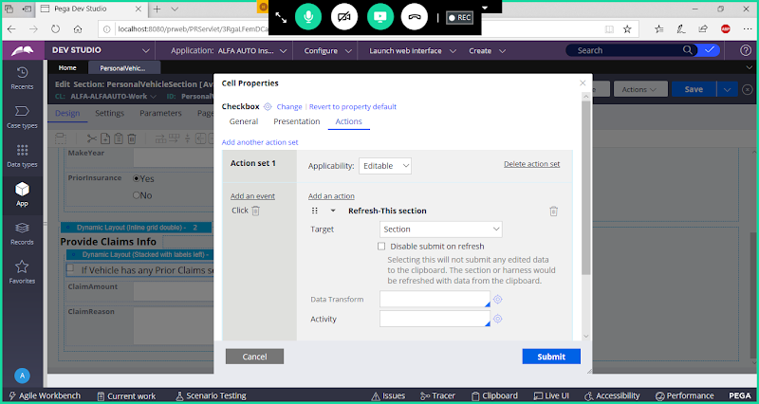

**Submit**

**Save section**

**Now test the section: Go to ACtions-> Run**

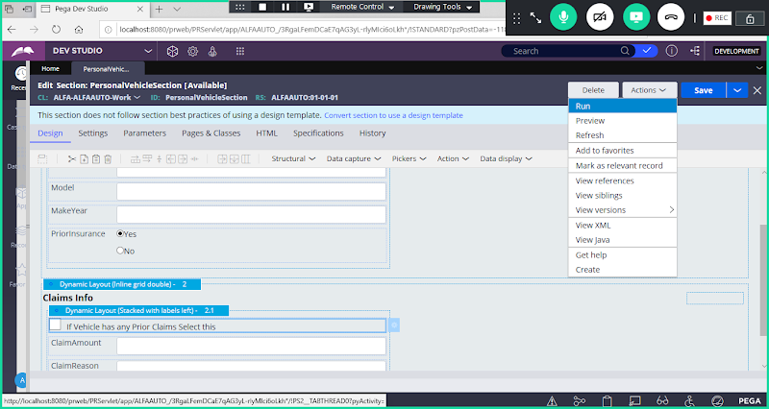

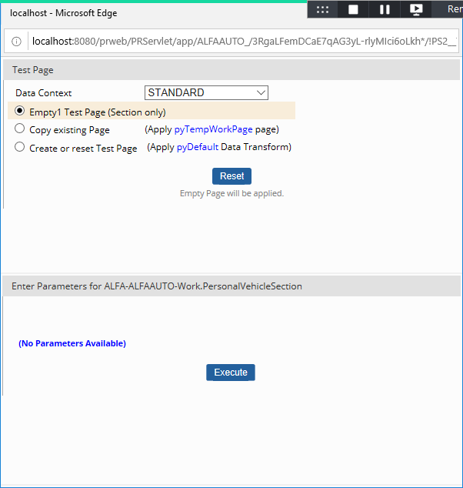

**Click on Execute**

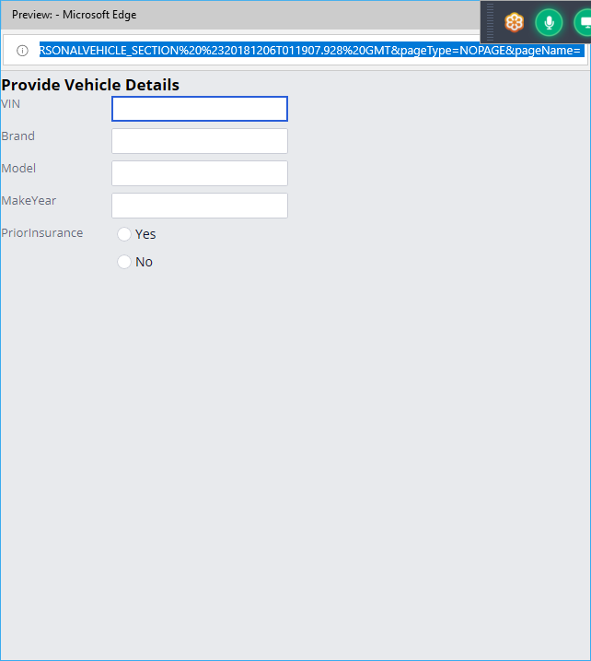

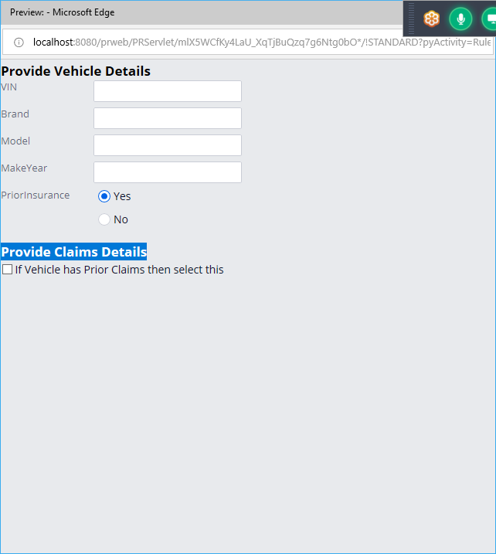

**Now Select CheckBox**

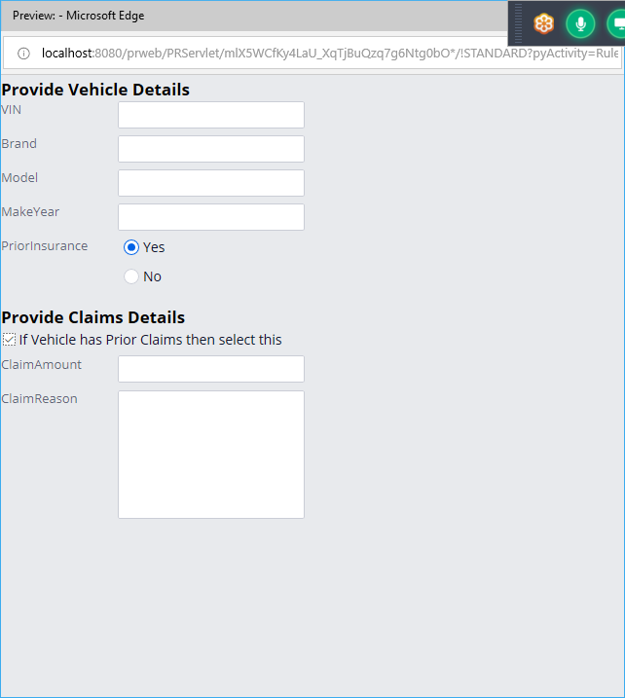

**Add a Flowaction:**

**Process-> Flowaction**

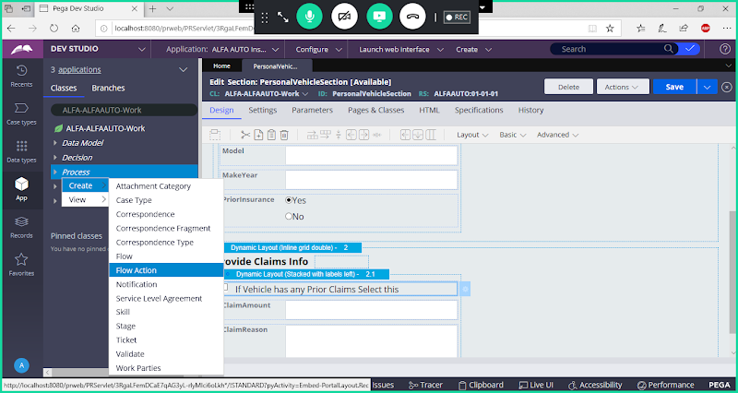

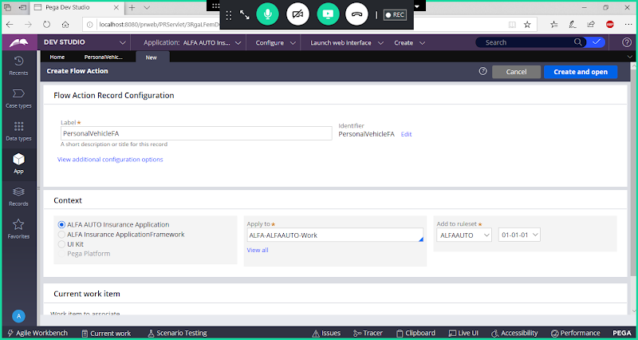

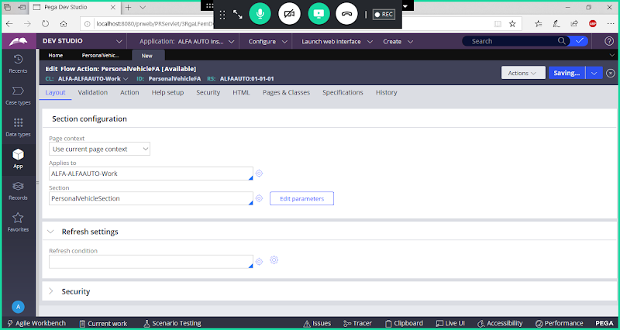

**Save Flowaction**

**Add A New Flow: Insurance Flow**

**Process-> Flow**

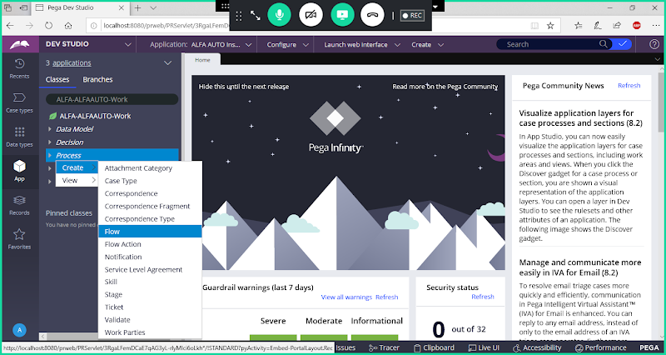

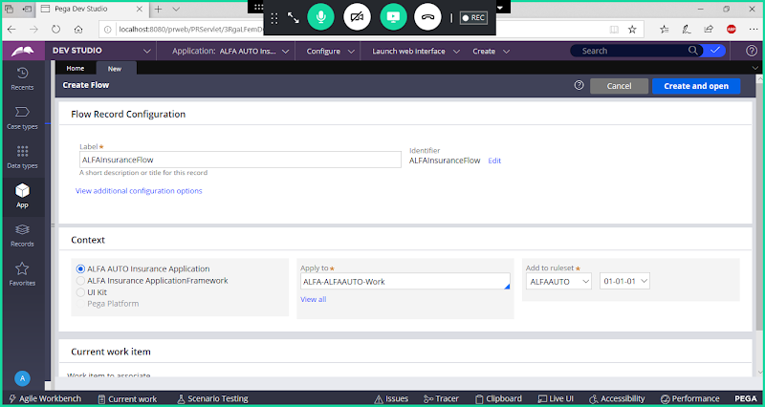

**Add Customer & Personal Vehicle Details Flowactions in Insurance Flow**

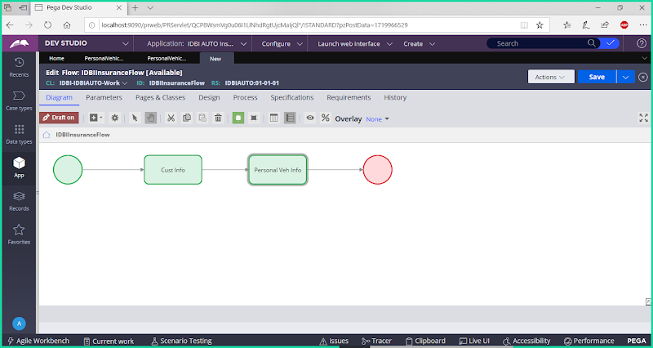

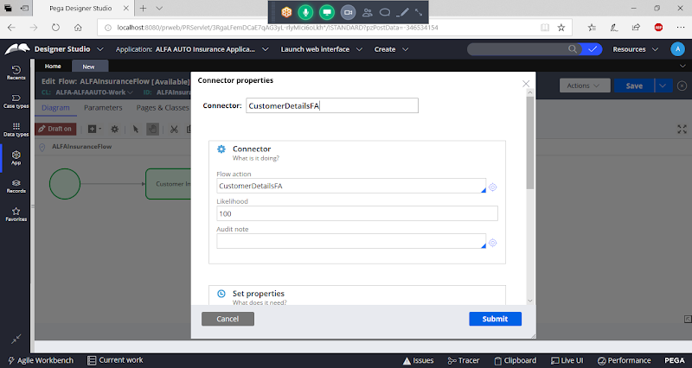

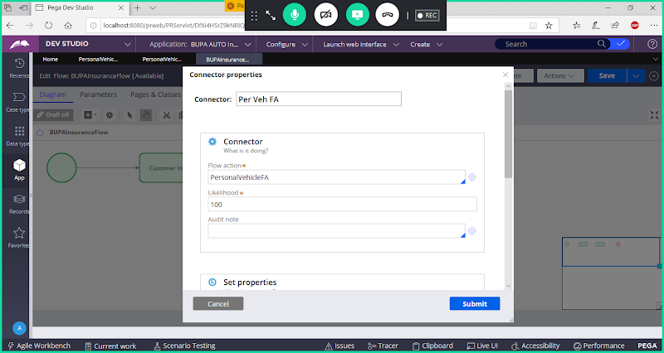

**Submit**

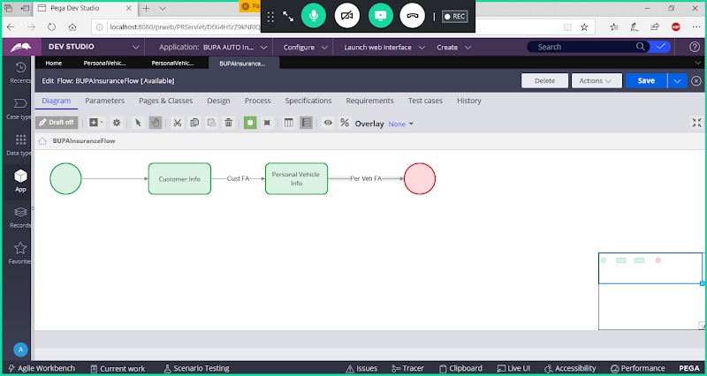

**Save Flow & run the flow**

[**Pegadump84@gmail.com**](mailto:Pegadump84@gmail.com)**–**

[**Pegabpm7@gmail.com**](mailto:Pegabpm7@gmail.com)